INTERNAL BACKEND

CUSTOMER MANAGEMENT

* Ability to Add or Delete customers
* Ability to Export all custom details, or subset of them/information based on a specific search parameters
* Ability to search customers by
  + Contact Name
  + Company Name
  + Customer ID
  + Email
  + Phone #
  + Postal/Zip Code
  + Country
  + Customer Group
  + Date Registered [range]
  + Points Total [range]
* List of customers shows:
  + Customer ID, Name, Account Email, Company, ‘Group’(for discounts), Country, Sign Up Date, Points Total
* Once a customer is found ability to access via a single click:
  + View Account information (all information from the edits in next point)
  + Edit Account information
    - Customer account information should include:
      * Main Contact Name
      * Main Account Login Email
      * Company Name
      * Multiple address consisting of (Recipient, Address 1, Address 2, City, Province/State, Country, ZIP/Postal Code, Tax ID #, Phone Number, Fax Number, Ship To Email with multiple emails possible [all order contact systems send email here except invoices], Bill To Email with multiple emails possible [invoices only sent here])
      * Broker Information Storage (Broker Name, Address, Email, Phone Number)
      * Freight Account # (Company[FedEx/DHL/UPS/KWE/Local/Other], Account #)
      * Account Rep (ABM Staff Member)
      * Account Notes (displays on order placement and order viewing pages)
      * Account Alerts (special display on order placement and order viewing pages)
      * Tax Exempt Status (some government or other institutions are tax exempt, this feature should prevent taxes being added to their orders regardless of the ship to location, and be settable for both GST/HST and PST separately)
  + View Loyalty Points Totals for Account
    - Including total ‘active’ points, all earning transactions, all sending transactions, all not yet valid points
  + View Past Quotes for Account
  + View Active Discounts for Account
    - Once viewing discounts, ability to change their discount group
    - Add additional discounts which override their group discounts (both category specific and individual product specific; individual product specific discounts should override all other discounts)
  + View Past Orders for Account
  + Place a New Order for Account
  + Send Reset Password Link

ORDER MANAGEMENT

* Order Placement Features [internal]:
  + Ability to input multiple SKUs with Quantities all at once (i.e. similar to ‘Quick Order’) with them adding to a ‘cart’. Once item(s) pulled up displays:
    - SKU
    - Current Amount in Stock
    - Current Amount On Hold on Other Orders
    - Product Name
    - Unit Size
    - Original List Price (adjustable) and Geo-priced based on customer’s account Country (1x in USD – USA, 1.15x for most items/1.3x for equipment in CAD – Canada, 1.5x in USD – Rest of World [1.5x pricing for rest of world reverts to 1x is the customer account has a discount for the item])
    - Quantity being Ordered (adjustable)
    - Original Subtotal (Original List Price x Quantity Ordered)
    - Discount % (based on discount level for account for the item and also adjustable)
    - Discount Value (Original Subtotal x Discount)
    - Sale Price (Original Subtotal – Discount Value)
  + Ability to Add ‘Miscellaneous/Custom’ Items:
    - SKU
    - Name/Description
    - Unit Size
    - Unit Price
    - Quantity
  + Ability to Remove Individual Item from ‘cart’
  + Ability to Remove All Items from ‘cart’
  + Ability to make ‘cart’ into Quote
    - see Quote System section for details
  + Ability to add notes for the Product Line Items
  + Ability to make ‘cart’ into Order (i.e. Check Out) – ***Quote System links in here****
    - Upon checkout the follow occurs:
      * Stock is deducted from the inventory (remember to consider ‘Component/Bundle’-like items) – ***and remember the stock status on the order at the time of its placement***
      * Emails are sent out to staff for any items that result in inventory <0 after the order, these emails are targeted to specific staff based on the item going out of stock. Also ability to set this threshold at different levels for different product groups (i.e. PCR). This email would ideally contain a link to help production staff add the items to the CSL efficiently. Also, if out of stock product does not match to send an email to any staff, send to [ryan@abmgood.com](mailto:ryan@abmgood.com) for appropriate distribution.
      * Inputs for:
        + Ship To/Bill To Addresses for the Account are auto-populated with the ability for staff to edit or add new address, which is used for the order as well as stored into the account for future usage
        + Customer’s Freight Company and associate Account Number auto-populate but still editable
        + Shipping Fee field
        + Bank Fee field
        + Order Department (Ready, Lenti, Adeno/AAV, Cell, Cloning, PCR, Buy, Custom, NGS, Deposit, China)
        + Estimated Shipping Date
        + Notes for the Order (pulls from quote if order being created from a quote)
        + Terms

Net30

Net45

Net60

Net90

Due upon Shipping

Prepayment

“Other” with input field

* + - * + Payment Method input:

PO #

PO# field

Wire

PO# field

Account Credit

PO# field

VISA/Mastercard/AMEX:

Customer ID# field

Card Name field

Card Number field

Card Expiry field

* + - Once information inputted and staff ‘Proceed’:
      * System calculates order Subtotal (SUM of all rows “Sale Price”)
      * System calculates taxes based on Subtotal + Shipping Fee
        + Two calculations:

(Subtotal + Shipping Fee) x GST/HST Rate for Ship To Province/State [rates need to be editable as occasionally change]

(Subtotal + Shipping Fee) x PST Rate for Ship To Province/State [rates need to be editable as occasionally change]

* + - * System calculates Grand Total (SUM Subtotal + Shipping Fee + GST/HST Amount + PST Amount + Bank Fee)
* Ability to search placed orders by:
  + ABM order number
  + Customers PO number
  + Company Name
  + Recipients name (Recipient in the Ship To Address field)
  + Order Placement Date
  + Ship/Pack Date
  + Estimated Shipping Date
  + Department
  + Pending Status
  + Hold Status
  + Grand Total (range)
  + SKU on the order
  + Status (i.e. Open, Completed, Cancelled)
  + Payment Status (i.e. Paid, Unpaid)
* Ability to view list of placed orders based on above search:
  + Displays order #, customerID, customer company name, PO#, date order placed, date order confirmed, date that all items are fully shipped, invoiced date, grand total of order, payment status
  + Highlight:
    - Orders in “HOLD” status – purple
    - Orders in “PENDING” status – light blue
    - Orders placed on current date and confirmed – yellow
    - Orders placed on current date and not confirmed – orange
    - Orders cancelled – red
    - Orders fully shipped and invoiced (i.e. ‘Complete) in green
* Ability to view individual placed orders with the following displaying and functions:
  + Display all line items on the order (SKU, name, unit size, list price, qty ordered, in/out of stock AT THE TIME OF ORDER PLACEMENT (i.e. if a later order brings the SKU to being out of stock this should not change in each respective order), item subtotal before discounts, discount %, discount amount$, line price after discount) with Subtotal, Shipping Fees, GST/HST, PST, Bank Fees, Grand Total
  + Direct link to the CSL listing(s) for the order
    - ***see other section for CSL specific requirements***
  + Edit/View Order Specific Shipping and Billing information, including payment type (ensure cc details encrypted and password protected), freight company details and Tax ID #.
  + Edit/View Product Line Item Specific Notes (visible to customer as well on order documentation included order confirmation, packing lists).
  + Edit/View Order Notes specific to the order (visible to customer as well on order documentation included order confirmation, packing lists).
  + Edit/View Internal Order Notes specific to the order (not visible to customers)
  + Edit Orders by:
    - Removing items (should return stock to inventory and be permissions based)
    - Adding items (should remove stock from inventory and be permissions based)
    - Adjusting shipping/bank fees

NOTE: when any of the above edits are done the Subtotal, Taxes and Grand Total all need to be re-calculated.

* + Ability to send an order confirmation to the ‘Ship To’ email with the following information:
    - ABM’s contact information, including address, tel #, fax #, email and our GST/tax number
    - Order Number
    - Order Date
    - Bill and Ship information from the order including email addresses
    - Customer’s PO # (or alternative words if VISA/Mastercard/Wire)
    - Estimated Shipping Date
    - Line Items placed on the invoice (SKU, quantity, unit, description, list price [discount % and discounted price, if applicable only], final line cost)
    - Subtotal, Shipping, GST/HST, PST, Bank Fees, Grand Total
    - Freight Method and Freight Account Number
    - Order Notes
    - Disclaimer/Terms “Note: Customers outside Canada may be subjected to an additional taxes, duties, inspection or brokerage fees for cross-border delivery.  
      Products are for research purposes only. Not for human or animal consumption.  
      ***This is an estimated ship date only, and may change without notice. For the latest update, please email order@abmgood.com and cite your confirmation number.  
        
      **Terms and Conditions**  
         Products are sold and licensed for use by end-users only for research or laboratory use and are not to be used on humans or for clinical diagnostic or drug purposes. Any use of Products for diagnostic or therapeutic purposes, or any purchase of Products for resale (alone or as a component), requires a separate license from Applied Biological Materials Inc. The purchase of Product does not grant any right or license to use such Product in the practice of any methods covered by abm patents or applications.  
        
      **Terms of Payment**  
         For PO's from pre-approved institutions, the terms of payment are net thirty (30) days from the date of shipment. A 1.5% service charge per month is added for accounts over 30 days.  
        
      **Changes or Cancellations**  
         Changes or cancellations to orders involving custom service or prioritized out of stock items prior to shipment are subjected to a reagent recovery fee of 20% of the custom service and/or product price, this is in addition to any applicable deposits. All custom service orders are final sale.  
        
      **Shipping**  
         Orders within Canada are shipped Monday-Thursday, orders to the USA are shipped Monday-Wednesday, and orders outside Canada/USA are shipped on Friday or Monday. Products are shipped F.O.B. Vancouver, Canada, shipping charges are prepaid and added to your invoice and unless otherwise requested, orders are shipped via Federal Express Priority.  
         For all non-Canadian orders, please note that customs clearance is not in our control. Applied Biological Materials Inc. recommends the use of FedEx as a broker for the most efficient and timely clearance of shipments.  
         In the event of shipment damage or errors in the products packaged, a picture showing the sealed foil pouches is required to verify damage/errors, and should be reported within 7 days of receipt of the shipment.  
        
      **Warranties**  
             abm makes no representation or warranty regarding the existence or validity of Third Party rights. abm does not warrant that any customer's use or resale of goods delivered hereunder will not infringe the claims of any patents, trademarks or copyrights of any Third Party. These warranties are exclusive, and abm makes no other warranty, expressed or implied. The use of Biological Materials may require a license from a Third Party, or be subject to restrictions that may be imposed by a Third Party. The Buyer agrees to have the sole responsibility for obtaining any intellectual property licenses required by a Third Party for their possession & use of the Biological Materials. The Buyer expressly acknowledges that the Biological Material provided does not grant the aforementioned license nor does it imply any ownership rights relating to the Biological Materials.  
          abm's products are warranted to meet our QC testing standards at the time of shipment. Notice of problematic products must be made to abm within 10 days of receipt of the product. This product warranty limits abm's liability to the replacement of the product only. Under no event, shall abm be liable for loss of profits, failure of research results, or direct, indirect, punitive, incidental, or consequential damages, including but not limited to loss of research or development, anticipated profits or economic loss. If all the above are not acceptable to you, return the products to us as soon as possible. Failure to promptly return the product constitutes the acceptance of the above terms.  
        
      **Guidelines for Safe Use of the Products**  
         Applied Biological Materials Inc. recommends that the buyer and other persons using the products follow Good Laboratory Practice guidelines. abm disclaims any and all responsibility for any injury or damage, which may be caused by the failure of the buyer or any other person to follow said guidelines. It is the user's responsibility to determine the applicability of any material and/or procedure for a specific purpose and to adopt such safety precautions as may be necessary.  
        
      **Research Use Only**  
         Products sold by Applied Biological Materials Inc. are all intended for research purposes by qualified persons only.”
  + Ability to Auto-add any Out of Stock items into the CSL
  + Ability to make split packing lists and invoices on the order
    - ***see section specifically for Packing List and Invoice for additional requirements***
  + Ability to “Complete” orders (separate from them being paid), ideally would happen automatically once all items are shipped and invoiced
  + Ability to put orders on “Hold” (separate from department assignments)
  + Ability to put orders as “Pending” (separate from department assignments)
  + Ability to mark orders a “Special/High Priority” with associated CSL entries being marked correspondingly
  + Ability to Cancel the entire order (should return stock to inventory), having a prevention in place if there are ‘Active’ packing lists or invoices
* Packing List
  + Ability to split ship items on an order (e.g. if only 20 of 40 on order are ready making a packing list for only 20 not 40), and also ship some lines on the order but not others
  + Ability to specify a future or past shipping date to appear on the packing list
  + Packing List should display:
    - ABM’s contact information, including address, tel #, fax #, email and our GST/tax number
    - Order Number
    - Packing List Date
    - Bill and Ship information from the order including email addresses
    - Customer’s PO #
    - Line Items placed on the packing list (“CheckBox”, quantity, SKU, unit, description)
    - Notes from the order (not the internal ones)
    - “Package Verified By:” with space for shipping team to initial/sign
    - “Products are for research purposes only. Not for human or animal consumption.”
    - Editable line or two where temporary promos or offers can be setup via a function to appear on all packing lists.
  + Ability to store lot numbers (can be on the order’s items notes but displaying here would be required for the future [this is noted in NEW FEATURES AS WELL]
  + Ability to email customer ‘Ship To’ email a summary email of the items being shipped to them and the tracking number so they have advanced notice of the shipment, however make this a Check Box or similar yes/no ability as in some cases we will not want to send this immediately to the customer
  + Ability to delete packing list and this adjusts the shipping numbers for the items on the order accordingly
  + Ability to store packing list specific tracking number and shipping date (may be different than packing date)
* Invoicing
  + Ability to split invoice items on an order (e.g. if only 20 of 40 on order are shipped making an invoice for only 20 not 40), and also invoices some lines on the order but not others
  + Ability to specify a future or past invoice date to appear on the invoice
  + Invoice should display:
    - ABM’s contact information as ‘Remit To’, including address, tel #, fax #, email and our GST/tax number
    - Invoice number generated by system (“order number”-“invoice for the order, i.e. 55689-1, 55689-2, etc)
    - Invoice Date
    - Bill and Ship information from the order including email addresses
    - Customer’s PO #
    - Due Date
    - Terms
    - Overdue Interest
    - Date the Order Shipped and via which Company
    - Line Items placed on the invoice (SKU, quantity, unit, description, list price [discount % and discounted price, if applicable only], final line cost)
    - Subtotal, Shipping, GST/HST, PST, Bank Fees, Grand Total, Amount Paid
  + If an invoice is ‘Paid’ adjust the Invoice wording on it to ‘Receipt’, with ability to still say ‘Invoice’ if customer requires it
  + If an invoice is for a ‘Prepayment’ terms order, adjust the Invoice wording on it to ‘Proforma Invoice’
  + Auto-calculate a ‘Due Date’ based on the Invoice Date and terms (i.e. Net30 add 30 days to the invoice date, Net60 add 60 days to the invoice date, etc) of the order
  + If the invoice is printed on a date after the ‘Due Date’ have the words ‘Over Due’ show up in red below the Grand Total
  + Have the Bill To information on the left-hand side and the Ship To information on the right-hand side so when putting in an envelope to mail the correct information shows in the letter window
  + If invoice’s Grand Total = $0, automatically mark as “Paid”
  + Function for finance to mark an amount of funds received, and if the total received for the invoice = the invoice’s Grand Total, then automatically mark as “Paid” and record the ‘staff’ and date/time of inputting these payments
  + Place for inputting internal notes on the invoice, mainly regarding specifics around the payment and record the login name of the staff member inputting the notes
  + Ability to delete invoices, when this is used an email automatically goes to [finance@abmgood.com](mailto:finance@abmgood.com) and this adjusts the invoiced numbers for the items on the order accordingly

SALES NUMBERS

* Ability to look up sales with a function similar to that on the old website:
  + Search by: SKU, Product Group, Supplier, Location of Sale, CustomerID, Shipped Status, Order Value cutoff, Date Range, Quoted Order
  + Resulting Display shows: Order Number, Date of Order, SKU, Customer Company, Customer, Location, Product Group, Product Name, Quantity Ordered, Total Final Value of Sale, Ship Status
  + Export Results to Excel with the following information/fields: Id, OrderId, OrderNo, CustomerId, Sku, ProductName, qty_ordered, qty_shipped, qty_invoiced, Total, OrderDate, ShipDate, OrderStatus, csn, ssn, dsn, library, system, source_table, csn value
  + Conduct the Export of Results outside of the backend system, similar to the desktop program Tony made Ryan for Magento, information as above should be exported. Ideally this export could be done accordingly to order placement date and item shipping date
* Break down of sales by all countries over a specific date range:
  + Displays Country (include Canada as a whole and breakdown for each of the 10 provinces), Items Sold and Total Sales
  + Export of this data to Excel

CSL(CUSTOM SERVICES LOG)

* Stores and displays a production record for any custom service and out of stock items including: Order#, Order Date, Number of Days since Order Placed, Customer #, PO#, Quote #(if there is one), SKU, Quantity, Description of Product/Service, Sample ID, Original ESD, Current ESD, Current Employee Working on Project, Notes, Special Requests, Date the Completed Item Shipped[auto-linked/updated when put on a packing list]
* Features:
  + Link directly to the display page of the order
  + Link to a pop up displaying the Notes (all) on the order
  + Add/Edit Sample ID field
  + Current ESD linked with that on the order itself and editable (Original ESD should not be editable and remain as per original input)
  + Ability to assign order to next staff member in production queue, this should send an email to that staff member and allow the assigning staff member to input notes on the location of the materials or other details pertaining to the transfer
  + Ability to ‘Complete’ the order, this will send a notification to the order team so they can release the order
  + Ability to add new Production Status Notes (this should be additive and not delete/overwrite prior notes inputted here)
  + Ability to edit special requests
  + Ability to input a Shipment Date for record consolidation
  + Orders marked as “special” in the Order system, show up with a yellow background
* Other Functions:
  + Ability to look up an individual order (displays all associated product productions)
  + Ability to look up all orders assigned to a specific staff member
  + Ability to look up orders based on original order date [range]
  + Ability to look up fully ‘Completed’ (i.e. all items on the order in the CSL are ‘Complete’) but unshipped orders
  + Ability to look up all ‘special’ marked orders projects
* Interlinked with order system:
  + When item in the CSL is put on a Packing List in an order, CSL Ship Date field automatically has the same date inputted
  + Orders on Hold/Pending/Cancelled have a note show in the CSL of this so the lab can see

QUOTATION SYSTEM

* Ability to input multiple SKUs with Quantities all at once (i.e. similar to ‘Quick Order’) with them adding to a ‘cart’. Once item(s) pulled up displays:

SKU

* Current Amount in Stock
* Current Amount On Hold on Other Orders
* Product Name
* Unit Size
* Original List Price (adjustable) and Geo-priced based on customer’s account Country (1x in USD – USA, 1.15x for most items/1.3x for equipment in CAD – Canada, 1.5x in USD – Rest of World [1.5x pricing for rest of world reverts to 1x is the customer account has a discount for the item])
* Quantity being Ordered (adjustable)
* Original Subtotal (Original List Price x Quantity Ordered)
* Discount % (based on discount level for account for the item and also adjustable)
* Discount Value (Original Subtotal x Discount)
* Sale Price (Original Subtotal – Discount Value)
* Ability to Add ‘Miscellaneous/Custom’ Items:
* SKU
* Name/Description
* Unit Size
* Unit Price
* Quantity
* Ability to mark item as ‘Recommended’ additional item, for products we add to boost sales which the customer did not originally request
* Inputs for:
  + Ship To Address for the Account is auto-populated with the ability for staff to edit or add new address, which is used for the order as well as stored into the account for future usage
  + Currency
  + Quote Expiry Date
  + Aim of Project
  + Deliverables
  + Lead Time
  + Notes
  + Internal Notes (viewable by our staff only)
* Output Display: note the layout and the ‘Requested Product Total’ (i.e. non-recommend product totals) and the ‘Grand Total’ (i.e. non-recommended plus recommended product totals) and Recommended Items slot themselves as line between these two values on the quote display

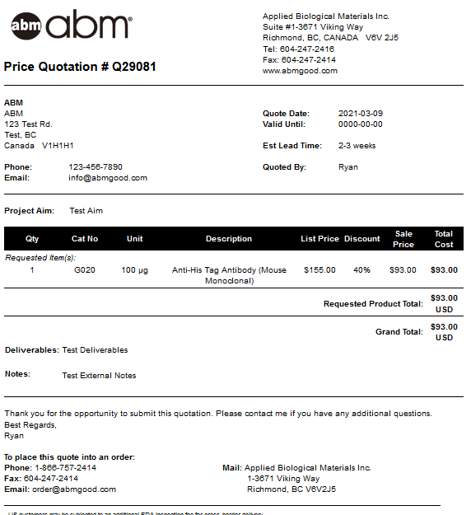

* + Other information stored and displayed: Date of Quote Creation, Staff Member Making the Quote
  + Notes as bottom of output: “- US customers may be subjected to an additional FDA inspection fee for cross-border delivery.  
    - Quote valid until expiry date listed on top.  
    - Total listed is subject to additional shipping and banking fees, and any applicable taxes or duties.  
    - Products are for research purposes only. Not for human or animal consumption.  
    - Lead time specified is from the date of order placement and is an estimate only, it does not reflect any possible technical difficulties during production.  
    - Cancellations of orders involving custom service items after placement and prior to shipment are subjected to a reagent recovery fee of 20% of the custom service price, this is in addition to any applicable deposits.  
    - Requestor acknowledges and agrees that Requestor’s use of Biological Materials may require a license from a Third Party, or be subject to restrictions that may be imposed by a Third Party. ABM makes no representation or warranty regarding the existence or validity of such rights. Requestor agrees to have the sole responsibility for obtaining any intellectual property licenses required by a Third Party for their possession & use of the Biological Materials. Requestor expressly acknowledges that the Biological Material provided does not grant the aforementioned license nor does it imply any ownership rights relating to the Biological Materials.”
* Ability to edit quote after initial creation (add/remove items, edit functions for all of aim, deliverables, lead time, notes, internal notes, ship to address/information
* Ability to turn quote into order (Check Out), which transfers:
  + all the Line Items
  + Into the Orders Notes (quote number, lead time, aim, deliverables, notes, quoting individual/staff)
  + Into the Internal Notes (quote internal notes)
  + For other order required information this flows into the order placement ‘Check Out’ process to get same payment/shipping fees/taxes/etc

DISTRIBUTOR DISCOUNT SYSTEM

* Customer Specific Special Numeric Pricing: this is the highest level discount and overrides all other % based discounts, is a SKU specific price for the customer
  + Ability to add/edit/delete these
  + Should interact with front end cart is customer logged in, and backend cart/quote system for ABM staff
* Customer Specific % Discounts, this is the middle level discount and only overrides the Group Discounts for the customer group the customer is assigned to
  + Ability to add/edit/delete these which can be SKU or product group specific (csn/ssn/dsn and/or breadcrumb groupings)
  + Should interact with front end cart is customer logged in and void Geopricing when used, and backend cart/quote system for ABM staff
* Customer Group % Discounts, this is the bottom level discount and overridden by all other discounts mentioned above
  + Customers can be assigned/removed from a discount group
  + Ability to add/edit/delete these which can be SKU or product group specific (csn/ssn/dsn and/or breadcrumb groupings)
  + Should interact with front end cart is customer logged in and void Geopricing when used, and backend cart/quote system for ABM staff
* Ability to view all discounts applicable to a group and add/edit/delete
* Ability to view all discounts applicable to an account (including the group level ones) and add/edit/delete non-group discounts

FINANCE SYSTEMS

* Ability to look up all invoices from a single date, should display:
  + Invoice #, order #, customer name, grand total, product value, shipping value, GST/HST, PST, payment method, $ amount paid (if any)
* Ability to look up all invoices from a single account with paid/not paid filtering, should display:
  + Invoice #, order #, grand total, product value, shipping value, GST/HST, PST, payment method, $ amount paid (if any)
* Ability to look up all invoices based on a single payment date
* Ability to pull up all unpaid invoices older than a specific invoicing date
* Readily display cc orders to be charged, idea is you look up an order number and it displays:
  + Invoice Number, Customer Name, Grand Total, Card Information (cc number and expiry), Ship To Country, Currency of Order, GST/HST amount, PST amount, Shipping Fee, Bank Fees, Invoice Date
* Calculate and display all the billed shipping fees month by month and calculate the total number of orders shipped per month

INVENTORY SYSTEM

* Search up a SKU and displays:
  + SKU, Product Name, Unit Size, List Price, Supplier, Supplier CatNo, Inventory Location, # in inventory, # on hold for placed but unshipped orders, lot information
  + If the items is a ‘Bundle’ display all the above information for each component
* For ‘Components’ ability to look up all the kits (‘Parent Product’) the component is a part of
* Ability to view list of the orders that the SKU is placed but unshipped for and displays:
  + Order Number, Customer ID, Customer Name, Quantity on the order, Date Order Placed, Estimated Shipping Date for the Order
* Ability to view list of the orders that the SKU is placed in any status and displays:
  + Order Number, Customer ID, Customer Name, Quantity on the order, Date Order Placed, Estimated Shipping Date for the Order
* Ability to adjust the inventory number/location of the SKU
* Ability to store/add lot # information (Lot #, Production Date, Notes) and view this information for the SKU
* Ability to look up lot # information based on the SKU/lot number combination
* Ability to look up the current inventory for a specific group of products and view all at once (e.g. DNA/Protein Markers) to help purchasing assess inventory levels at once to plan purchases
* Ability to have ‘hidden’ products which only interact with backend system or ‘bundles’
* Allow products to be ordered which would take inventory to negative values and put the items on backorder

CS DATA RESULTS UPLOAD FUNCTION

* Ability to upload a file with associated data storage for Customer ID, Order #, One file (may be multiple separate uploads for one order), File Name that Displays on Customer Access Page

LOYALTY POINTS SYSTEM

* Search up a Custom Account and view all their points transactions:
  + Order #, Customer ID, Customer Company, points earned/spent, Eared Date, Validity(yes/no), Notes
* Ability to go into specific transactions and adjust them to different amount and add notes for reasoning
* Ability to exclude customer accounts from system (i.e. distributors, OEMs, other who request it)
* Ability for management staff to create special promos (e.g. the 2X PCR points offer)
* Points are not marked valid until the order is shipped and paid in full
* Sample orders for $0 are not to be considered ‘first order’ for 500 points
* Search Up (by Redeem Order #, CustomerID, Customer Company,Date Redeemed) and View List of all Redemption Orders:
  + List Displays: Order #, Customer ID, Customer Company, Date Redeemed, Prize Redeemed, Fulfillment Status
* Ability to view more in depth information of each redemption:

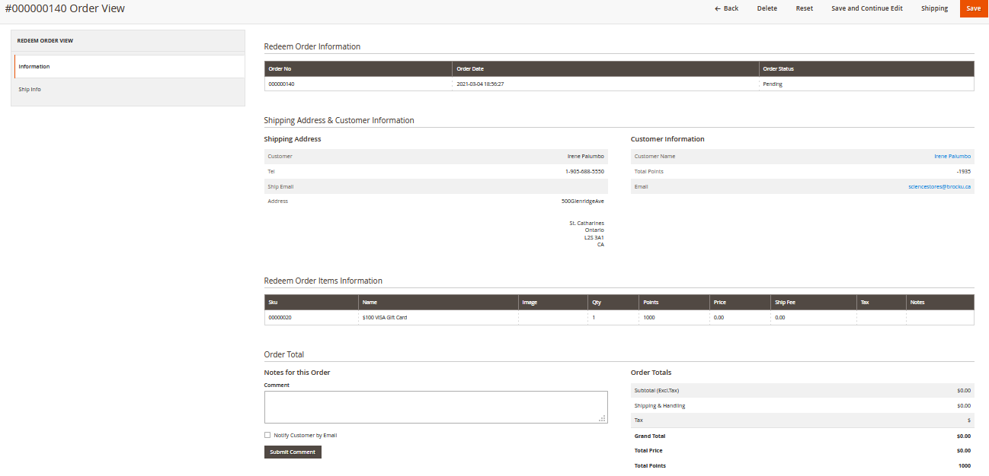

* + - Also ability to input ‘fulfillment’/shipment of reward information, and make as Completed/Fulfilled

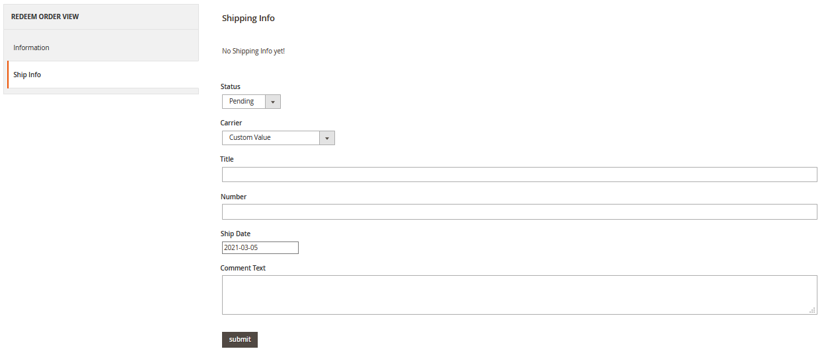

* Ability for Management Staff to input Prizes:
  + Current system and functions found here <https://www.abmgood.com/admin/loyaltymall/products/> work well as is, replicate exactly as is (adding ability/editing ability) and all fields (SKU, Name, Points Value, Description, Active/De-activate, Image, Notes)

DOCUMENT/REFERENCE/FAQ SYSTEMS

* Three systems like those on original site, where a file/question/reference can be input and then assigned to multiple SKUs and Product Groups (product group ability makes it easier than assigning to 100’s of individual products if relevant to all SKUs in a specific product group.
* Ability for logged in staff to directly access the ‘Edit’ feature for these on the product pages would be very helpful and more user friendly

SEO TOOLS

* Ability for staff to input meta tag information for pages to help SEO of products for Google

AUTO-ALERTS FROM SYSTEM

* Orders with a ‘folder’ other than PCR/BUY and associated entries not found in the CSL
* Orders two weeks from their ESD, co-email sent to order team, person responsible for the order currently and their supervisor (that are not ‘Completed’)
* Orders at their ESD, co-email sent to order team, person responsible for the order currently, their supervisor and Ryan (that are not ‘Completed’)
* CSL entries without a Notes update for 10 calendar days (that are not ‘Completed’)

CUSTOMER FRONTEND

DASHBOARD

* Current version is good, however additionally add a section for Orders in the Last 30 Days at the bottom of the page with quick link to all orders, overall would look something similar to the following:

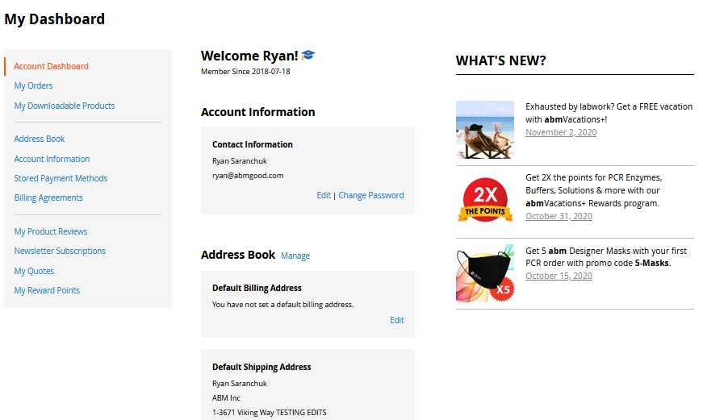

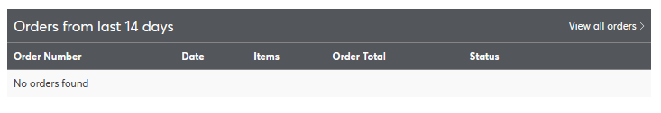

VIEWING OF PRODUCTS and PRODUCT PAGE ADD TO CART

* Once logged into, pricing on the pages should be automatically adjusted to price based on account/customer group level discounts, overriding Geopricing, or if no discount then Geopriced accordingly (int’l 1.5x USD | Canada 1.15x CAD for non-equipment and 1.3x CAD for equipment).
* If customer has added items to their cart before logging in, upon login should transfer from a ‘session ID’ cart to a cart for their specific account and retro-actively apply and show applicable discounts/pricing.
* Add to cart button on the product page, with multiple quantity fillable blank

SEARCHING OF PRODUCTS

* Better search function with more ability for us to tweak to our specific needs overtime (i.e. something similar to Sphinx on the old site) for keywords, relevance, etc.
* Better fuzzy searches
* Ability for customers to add the item to their cart directly from the search results
* Search Results Geopriced/Discounted too

BASIC ACCOUNT CREATION AND SELF-MANAGEMENT

* Ability to Login (email/password)
* Ability to Request Reset Password Email/Link
* Ability to Create Account:
  + Initially should just require Name, Email, Password
* Ability to add/edit additional account information:
  + - * Company Name
      * Multiple address consisting of (Recipient, Address 1, Address 2, City, Province/State, Country, ZIP/Postal Code, Tax ID #, Phone Number, Fax Number, Ship To Email with multiple emails, Bill To Email with multiple emails possible)
      * Broker Information Storage (Broker Name, Address, Email, Phone Number)
      * Freight Account # (Company[FedEx/DHL/UPS/KWE/Local/Other], Account #)
* Ability to change password/email
* Ability to view list of all placed orders on account:
  + Order #, Date Placed, PO# or Ship To Recipient, Order Total, Status(Open, Complete, Cancelled), if Complete the tracking number(s) should be displayed as well
  + Ability for customers to filter the list by Open/Complete/Cancelled or 3mth/6mth/12mth/”all” date range
* Ability to View details of individual orders, all this information is good, also needs printable view with same information but layout needs improvement moving Ship To/Bill To/Payment/Shipping Method above the items:
* 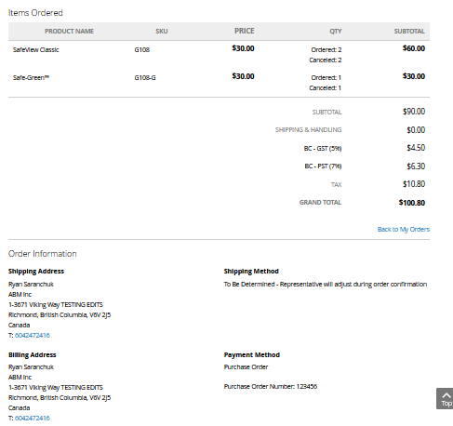
* Additional information to display pertaining to shipments for the order at the bottom of this page, including the tracking number and items shipped on that tracking number, please see an example as follows from a competitor. This order was for 50 qty of a single item and shows the 4 different shipments it was sent on (includes SKU & quantity shipped on each, date of each shipment, tracking number details for each shipment so the customer can directly track it) and if multiple different SKUs on a shipment show all on the single shipment
* 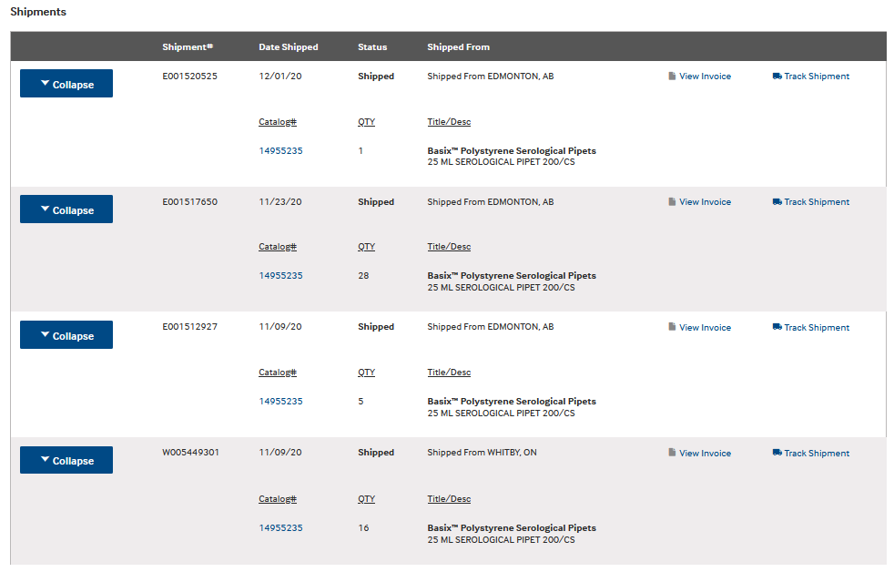
* Ability similar to the above mentioned “order view” and features (minus the shipments list) but for invoices as PDF printout with same information as ‘invoice section’ from backend
* Ability/Portal to download results for data based orders [associated with “CS DATA RESULTS UPLOAD FUNCTION” on internal backend]

LOYALTY POINTS SELF-MANAGEMENT

* Ability to ‘Order Rewards’ based on active points in their account, current version is good.

1) click on the reward:

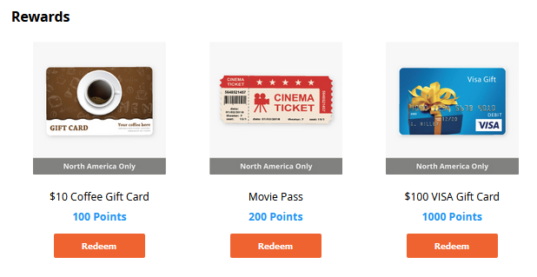

2) popup shows up where you agree to terms and submit:

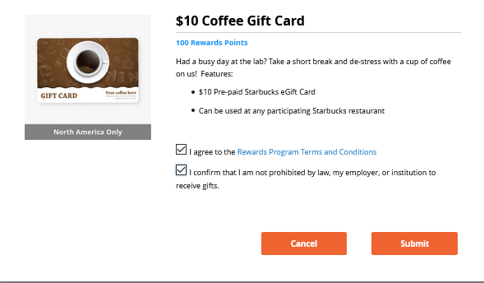

3) emails sent to [order@abmgood.com](mailto:order@abmgood.com) on the redemption and customer’s email on the account

* Ability to review History of Points and Current Balance, current version is good:



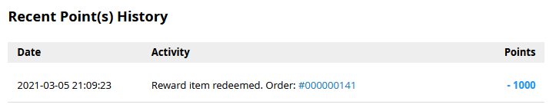

QUOTE VIEWING

* Current list with Quote #, Date of Quote and Status (Placed, Pending, Expired) is good along with the View option, however please remove the ‘Delete’ option. Customers should have the ability to Check Out a Quote AS IS without removing/adding/deleting anything, however have a choice between just the Requested items, or the Requested items plus Recommended items. If they need amendments then they will need to email/call us.

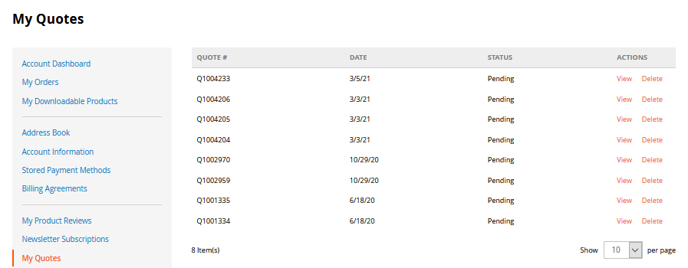

* Once on the ‘View’ page, most is there but should list a Grand Total for the items on the Quote, along with showcasing any ‘Discounts’ we have provided them on the quote. As well as a section and secondary total for any ‘Recommended’ products:

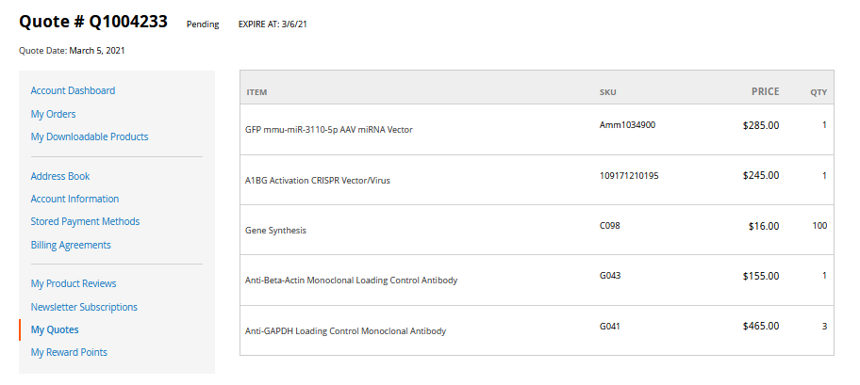

SELF ORDER PLACEMENT

* Quick Add to Cart function, current version with SKU, qty and Notes is good:

<https://www.abmgood.com/quick>

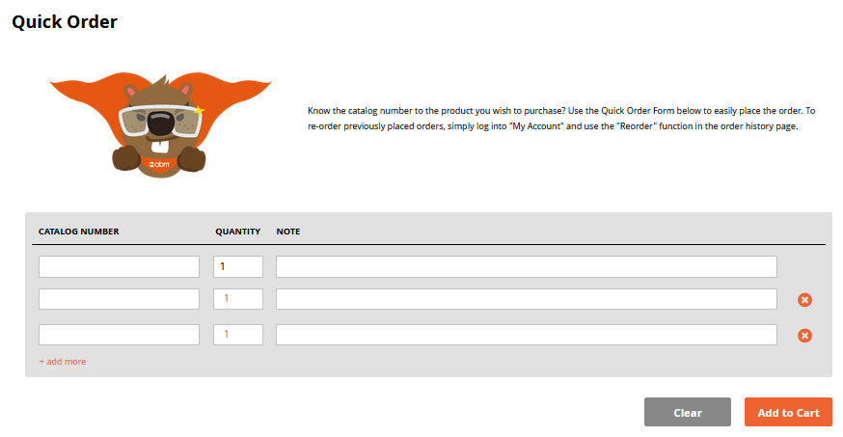

* Current shopping cart view and features are mostly good, however should have ability to add notes to items already in their cart (i.e. lot requests or similar details):
  + Line Item display should have SKU, Name, Current Availability (in stock or out of stock, Price, Quantity[editable], Line Subtotal, individual removal option
  + Subtotal Summary, Apply Promo Codes, Clear Cart and Update Cart (based on edits to the quantities), Check Out
  + Quick Order feature being display here is good as well

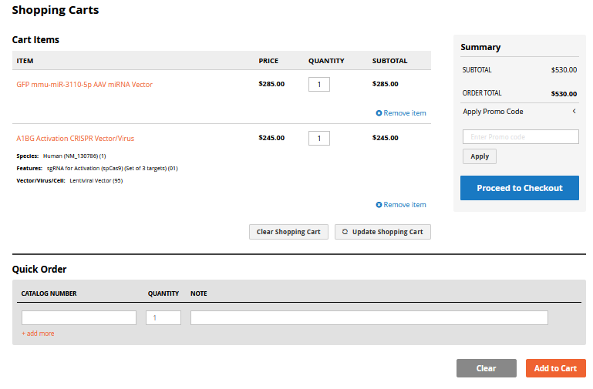

* First check out page with selection of existing addresses on account or addition of new one is good, however the ‘Shipping’ method needs to be fixed, fees will be added by staff confirming the order (or ideally auto-calculate ***see new features***). Customer should instead have the ability/field to add Shipment related Notes for our review upon confirmation (i.e. freight account #, request to send after certain date, etc).

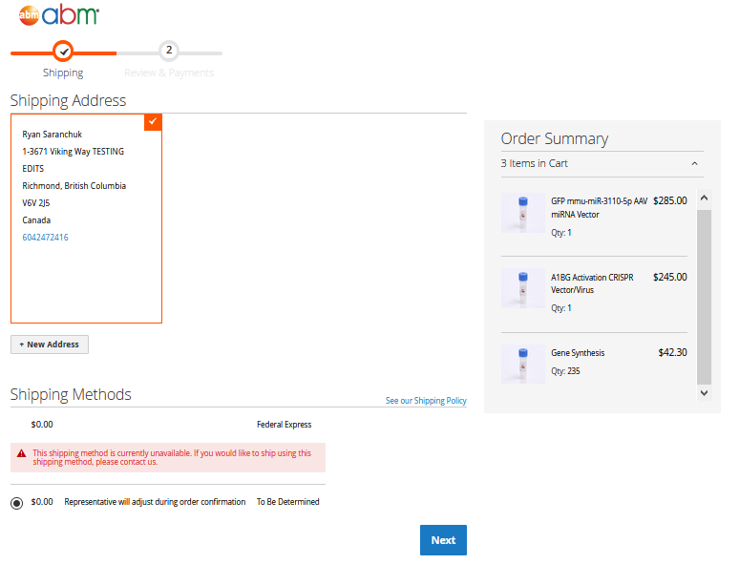

* Features on Payment page good for POs (PO# field) and credit cards (cc number, expiration date and CVN fields), however Wire Payment options should have the ability for customer to input a ‘Reference#’ (can be stored in same field as PO# in the database). Ability to choose existing account address or add new one. At this point taxes should be just TBD (until shipped fees auto-calculate) as they will change once our staff adds the shipping fee at order confirmation. As a suggestion the old website only calculated up to the ‘Subtotal’ at this point of customer order creation and then did the Shipping/Tax/Bank Fee/Grand Total calculations at the time of our confirmation/review of the order.

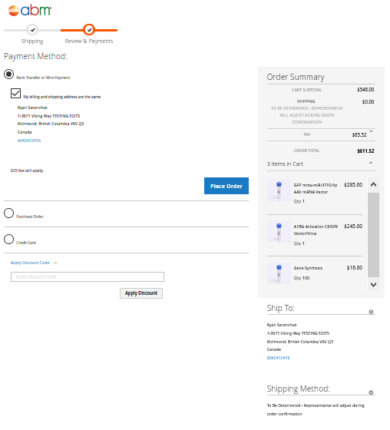

* Once customer places the order, similar stock deductions as our backend checkout, along with out of stock notifications to staff should occur, and in addition the order team should be sent a notification of a new online order being placed and customer should get a ‘Order Received’ email (they will also get another once our staff confirms the order). Notice that appears on the site itself is good, and the Order Received email sent to the customer could be similar and basic like this. Major details will be provided when we review and then send them the full order Confirmation.

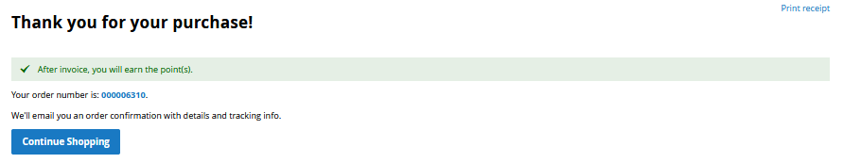

_____________________________________________________________________________________

Existing Miscellaneous Features/Abilities

* Google Analytics compatible
* Google crawling compatible and a format the reduces/eliminates “duplicate content”
* PDF upload capabilities on product pages, custom made pages by marketing (described previously) and other locations
* Mobile friendly/adaptive design
* All the Groupings/Pages on the Top Bar drop down:



* “Dashboard” with quick review of recent orders. Should contain Today’s Order Total # and Value, Yesterday ‘s Total Order # and Value, New Accounts Who Have Ordered in the Month, New Accounts Created in the Month, then a List of:
  + Order Number
  + Company
  + Subtotal
  + Items on Order
    - (today’s orders in orange and all previous in black

{current version works well]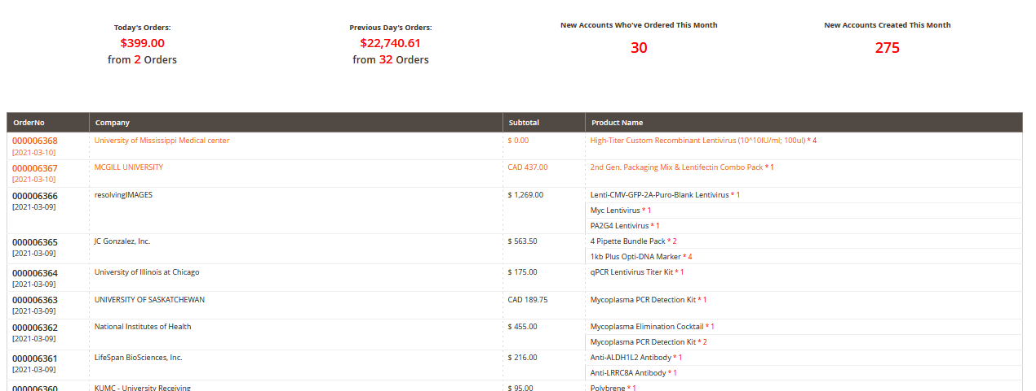

* Summary of Search Terms used in the onsite search feature to help identify any trending terms and any terms that should be working and are not (e.g. “ef1a” on current site)
* Ability for ‘Admin’ to look up internal user accounts, add/delete/edit, adjust permissions. Current version works okay, however permissions should be clearer in the new version
* Ability for marketing staff to custom create pages for their sales/promotions/etc purposes.
* Promo Code ability/logic (based on product groups, value of specific products and groups of products, discount possibly applied to shipping/products/other free items) Currently version on Magento has all the functions we should need but the logic is broken and/or difficult for most people to follow and setup codes correctly.
* For ALL lists described above (in entire file), have the ability to sort them by the different columns showing
* For ALL lists described above (in entire file), have the ability to export them to Excel for external data review/processing

_____________________________________________________________________________________

New Features

* Integration with FedEx Ship Manager desktop software, in order for shipping information to be pulled directly off of orders from the website database, to save time and reduce any transposition errors
* Ability for customers with Custom projects to log in and view the status of their project
* Licensing and Associated Royalty system (see previously supplied parameters from Ryan/Angela/Heidi)
* Interface for management to be able to modify the out of stock email list
* Interface for management to mass change the current employee of CSL entries (i.e. when someone leaves the company or role changes)
* Interface for management to add/remove staff from the CSL staffing options
* Ability to identify abandoned carts and send follow-up (automatic?) email to customer about their cart and ability for marketing staff to adjust the contents of this email should we want to offer promos/notices of programs/etc
* Ability for system to auto-calculate shipping charges, based on products, this will require storage of information in the product database such as weights/sizes/shipping conditions of all products
* When items get restocked to sufficient numbers, automatic email notification to order team and status change on the formerly out of stock orders, saving time and effort to shipping and order teams.
* Internal Purchasing System to be transferred from old site??? (if this is to be done more specific requirements will be provided)
* Method to record/store lot numbers shipped to specific orders, will aid in doing recalls or following up with problematic lots
* Have “Punchout” (cXML) capabilities where purchaser’s procurement system can directly interact/connect with our website and shopping cart to make a PO requisition on their end (for more detailed description https://www.punchout2go.com/frequently-asked-questions/.) This is something a platform partner brought up with us and Peter said we should design the capability for in our new site.
* CRM Integration capability for future custom management and more direct marketing to increase engagement
* Chat compatibility, can use ‘tawk.to’ as we previously did on old site, please ensure this integration is possible
* “Share” feature on the product pages to allow customers to share the information/product with colleagues via social media or other phone apps
* Ability to pull list of emails/name for orders shipped on date X so we could send them a link to do a satisfaction survey